Name: ____________________________________________________________________________ Date: ______________________________

Title – always provide a title (The Effect of the IV on the DV)
Axes – The X and the Y axes should be labeled appropriately, and units should ALWAYS be included! Put the IV on the X axis and the DV on the Y axis; also, keep in mind that you should keep the range of values and the spacing appropriate for the data given.
Key – if necessary, provide a neatly labeled key (if you are looking at several different variables within your IV)

*If it makes more sense to graph the average of the data provided, then do that! The idea is to show your data in a way that makes it easy to interpret.
Neatness counts!

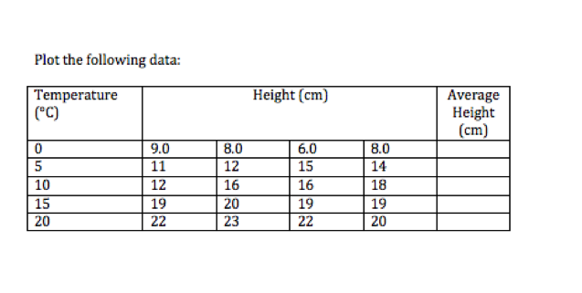
Title: _____________________________________________________________________________________________________

