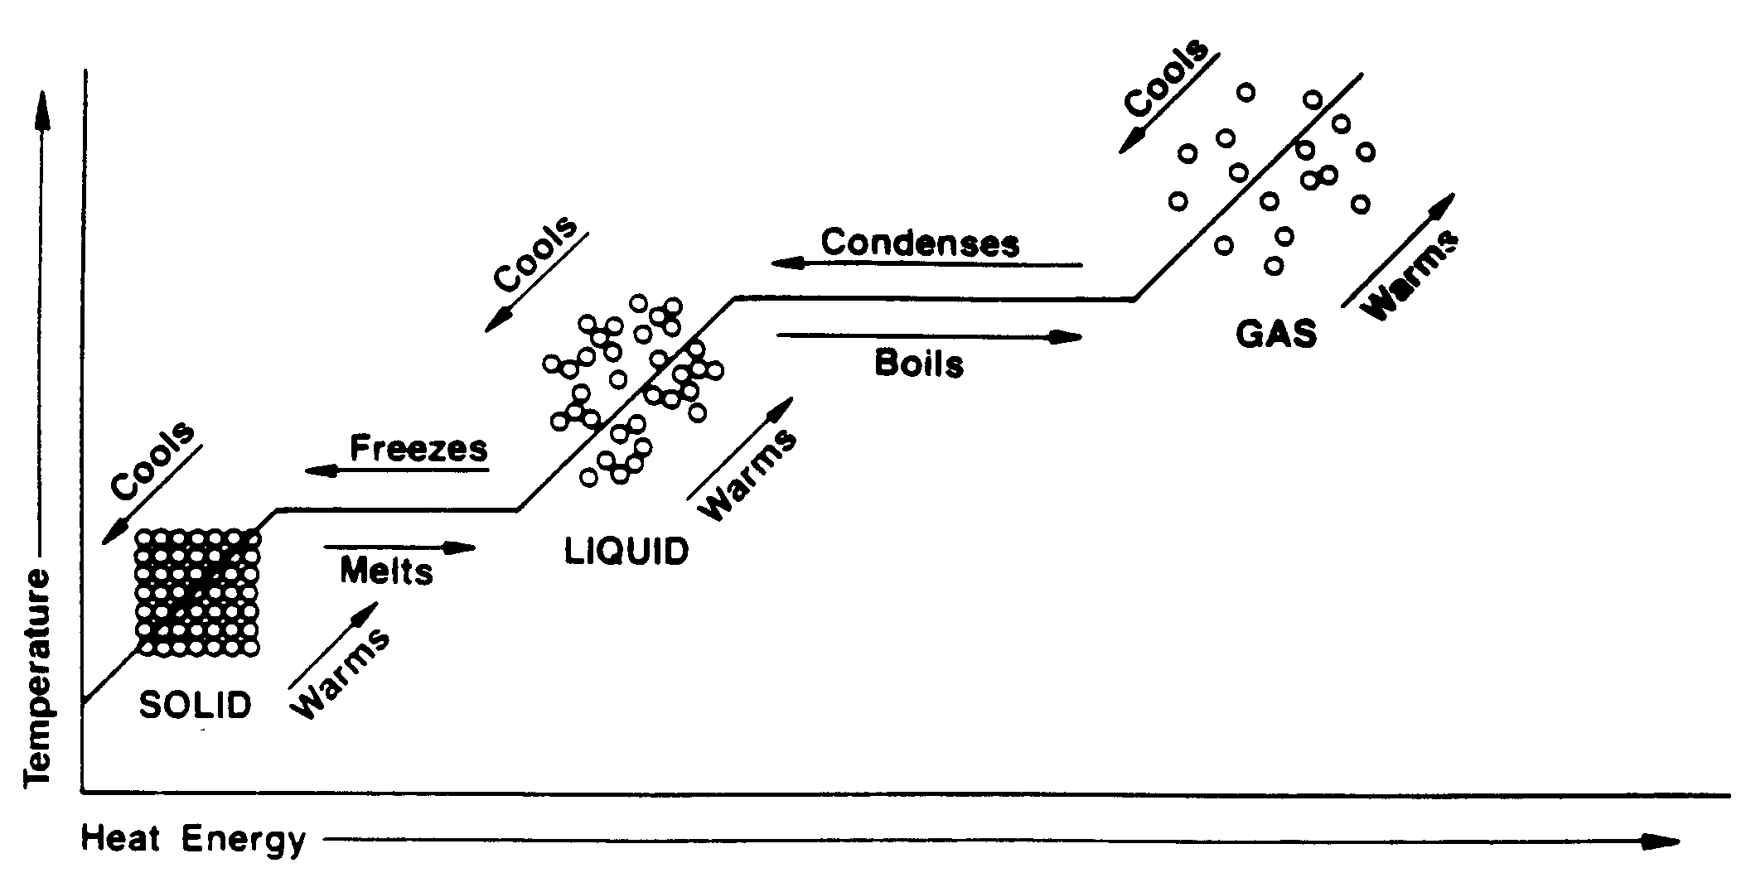

**Change of Temperature vs. Change of State**